**Basic Python**

1. **Split this string**

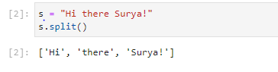

**2.Output should be: The diameter of Earth is 12742 kilometers.**

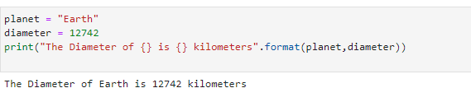

**3. In this nest dictionary grab the word "hello"**

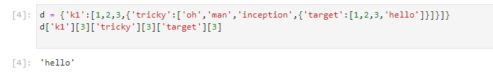

**Numpy**



**4.1 Create an array of 10 zeros?**

**4.2 Create an array of 10 fives?**

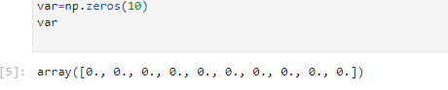

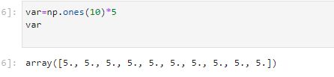

**5. Create an array of all the even integers from 20 to 35**

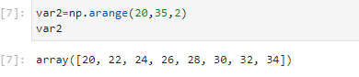

**6. Create a 3x3 matrix with values ranging from 0 to 8**

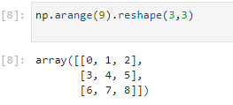

**7. Concatinate a and b**

**a = np.array([1, 2, 3]), b = np.array([4, 5, 6])**

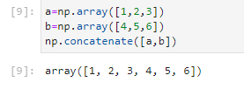

**Pandas**

**8. Create a dataframe with 3 rows and 2 columns**

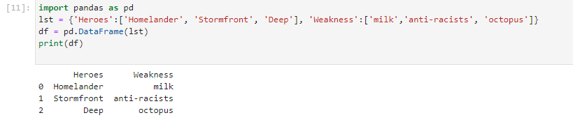

**9. Generate the series of dates from 1st Jan, 2023 to 10th Feb, 2023**

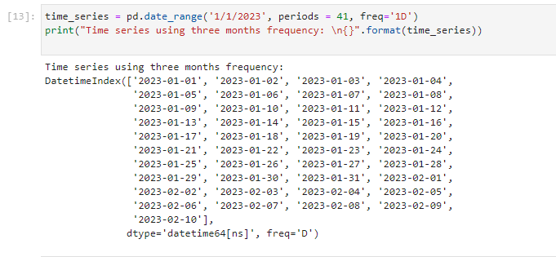

**10. Create 2D list to DataFrame**

